# The Different Elements of Digital Marketing and How They Can Help Your Business Succeed

Digital marketing can create a significantly high return on investment compared to its conventional counterpart. It costs cheaper and has lesser risks yet you can sow greater rewards. It also one of the most useful strategies these days, especially after the pandemic has pushed many companies online.

However, many companies don’t have a clear and defined [digital marketing](https://www.forbes.com/sites/forbesagencycouncil/2020/02/11/the-shocking-truth-about-digital-marketing/) plan. Because of this, many of them miss out on the fruitful results that it can bring. But, fortunately, you’ve come to the right place as we’ll get a closer look at the different elements of digital marketing and how they can affect your business’ growth. But first, let’s get to know what digital marketing is.

## 

## Digital Marketing

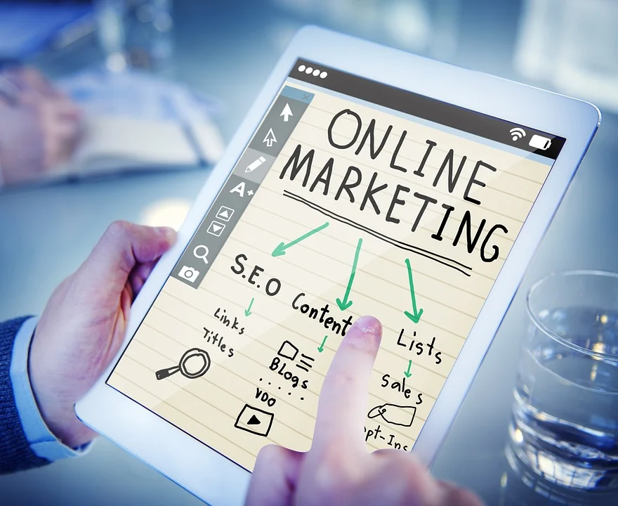

Source: https://pixabay.com/photos/online-marketing-internet-marketing-1246457/

Digital marketing helps you see what makes your business a cut above the rest and how you can make it known to your audiences using various digital channels. Through this, you’ll be able to grow your business as it helps you know your message and how you can send it effectively to your target market to make a profit.

It has so many benefits to offer. But then again, not many business owners know the elements of digital marketing. Thus, they aren’t able to make the most out of it and experience all of its benefits. Luckily, we can help you get to know them better. without further ado, here are some components of digital marketing and how they can help you.

### Search Engine Optimization

Also called SEO, search engine optimization is actually one of the keys to a successful digital marketing plan. This helps your page or website rank higher in search results, helping you to gain the trust of your target consumers.

Many consumers often don’t bother looking past the first page of search results. SEO wizards at [The Guerrilla Agency](https://theguerrilla.agency/) say if it’s not on the first page, then for the consumers, it’s not relevant or can’t be trusted. So, even if you have the best products or service to offer, if it doesn’t rank first on the results, they will never find it.

SEO, however, helps your page rank higher by creating quality content that will lead users to your page, helping them find answers to their questions. This will help your business get noticed as it makes your page appear on the first page of the search results. The higher you appear on the results, the more leads you’ll have. In turn, you can enjoy more revenue for your business.

However, it doesn’t happen overnight. Apparently, it is a strategy that you’ll have to pay attention to in order to maintain your ranking on the search results.

Google and other search engines often make changes in their algorithm. Google alone makes thousands of changes in its algorithm. And if you fall behind, it’s hard to come back. So, it’s really hard to maintain. Even so, it is worth investing in.

### 

### Pay-Per-Click Advertising

Pay-per-click advertising also referred to as PPC, is a digital marketing strategy that helps you maintain your online presence as you set up organic rankings with search engine optimization. This helps you increase your ranking in search results faster as it can start driving leads to your website even in just a few minutes your ads are put to work.

The good thing about this is that you’ll only pay per click; hence the name. You’ll only pay when people click your ads, which is great if you’re on a limited budget. With this, you can get good results without wasting your money trying to reach a market that isn't into your product or service. It’s effective, it’s organic, and it’s budget-friendly - perfect for start-up businesses.

### 

### Web Design

A web design is vital in driving leads back to your page. It leaves an impression on your prospective consumers. If it doesn’t load fast, users will likely leave your page quickly and look for other sites instead. Not only will you lose a potential customer, but you’ll also have no chance to share what your brand is all about and how you can help your target market.

The way your website appears also plays a huge factor. Let’s say your target market is gen z who are into trendy stuff. If your website looks straight out of the ’70s, you’ll probably not be able to keep them interested in using your page.

Visuals and user experience is everything in keeping your target market’s attention. Hence, you’ll want to match your web design with the interests of your target market, so they will keep on visiting and using your page. This way, you’re able to establish an image for your target market and it’s easier to make them more familiar with your brand.

### 

### Content Marketing

Content marketing also helps in boosting your ranking on search results. In fact, it can drive more leads up to three times than traditional marketing strategies. The good thing about this is that it also helps prospective customers to get to know your brand more.

Consumers are already bombarded with ads and it can be [a handful for many](https://www.business2community.com/strategy/improve-current-advertising-strategy-0783248). They are all tired of seeing thousands of ads. And to be honest, no one cares about such ads. What they want are useful and relevant pieces of information. And you can give them that through content marketing.

With content marketing, you’ll still be able to sell your products or services. But the good thing about this is that you can also get to answer your target market’s questions and help shed light on the things that are hindering them from buying from you. Through this, it’s easier to make your brand and products or services known without annoying your target market.

With this digital marketing component, you’ll be hitting two birds with one stone. You’ll not only get to rank up the first page of the search results, but you’ll also get to educate your consumers about your brand.

### 

### Social Media Marketing

People these days are glued to their phones mainly because of social media platforms. And the pandemic dramatically changed the way we use social media even more. Because of this, it is considered a valuable digital marketing component.

Social media marketing helps you connect with both your current and prospective customers. Plus, you’ll be able to build relationships with them more as it’s easier for them to ask their queries about your product and/or service via social media. Needless to say, it’s easier to answer their questions too.

Some social media platforms like Facebook also have chatbot features. Which will improve your current and possible customers’ experience and build rapport while you’re still unable to answer them, making them feel more valued and seen.

Additionally, it helps you to easily uncover the trends and insights about your customers’ opinions and thoughts on your services, products, brand, industry, as well as your competitors, which you can use to better your strategies.

Many social media platforms such as Youtube, Facebook, and Instagram also now allow their users to run paid advertisements to target and reach your tidal market. While it doesn’t come for free, it sure does help a lot too.

### 

### Email Marketing

Email marketing also helps you earn a good return on investment. With every $1 invested, you can earn more than $40. This, however, is more on nurturing your lead strategy. This means you already have interested consumers and you’ll just follow up with them and send them custom information about your products or services that interest them more.

The good thing about this digital marketing component is that you can personalize your emails more and base them on your subscribers’ interests and needs. Because you’re delivering a king of content that already resonates with them, you can expect greater results than other strategies available.

This might need some extra work, though, as you’re going to customize your emails based on your consumer’s needs and wants. Even so, it’s worth the effort. Don’t worry if you don’t have enough time to do this on your own as you can also automate your emails to your customers and still be able to get good results. This way, you can focus more on running your business.

### Marketing Analytics



Source: https://pixabay.com/photos/digital-marketing-seo-google-1725340/

The recipe to a successful marketing campaign doesn’t stop after your ads go live, after you sent emails, market via social media platforms, create content, or whatnot. You’ll also need to track and analyze your results too. This way, you’ll continue making more revenue and leads.

You’ll want to keep an eye on how well your strategies are performing too. You also want to monitor your conversion rates, as well as cost per head. Doing these will help you see how and where you need to improve on your marketing campaigns to reach more audiences.

Marketing your brand, services, or products is crucial in growing your business. It has to be done right using the correct marketing channels. These pieces of information will help you know which channels to use for you to be able to grow your business.