LOOKING FOR HOW TO WIN AMAZING PRIZES? CHECK OUT TECNO’S AUGUST SPECIAL SALE PROMO.

TECNO'S SPECIAL SALES PROMO IS FOR EVERYONE AND YOU DONT WANT TO MISS OUT.

TECNO HAS LANDED WITH ANOTHER AWOOF! CHECK OUT TECNO'S SPECIAL SALES PROMO AND SEE HOW TO WIN.

TECNO SPECIAL SALES PROMO IS LIVE! HURRY NOW AND WIN AMAZING GIFTS!

BE AMONG TECNO'S LUCKY WINNERS TO PARTAKE IN THE SPECIAL SALES PROMO.
WIN MOUTH WATERING PRIZES IN THE TECNO SPECIAL SALES PROMO
TECNO GOT YOU COVERED WITH EXQUISITE PRIZES IN THE SPECIAL SALES PROMO
WIN HEADSETS, GIFT BAGS, SOLAR PANEL AND OTHER INSTANT GIFTS IN THE TECNO SPECIAL SALES PROMO
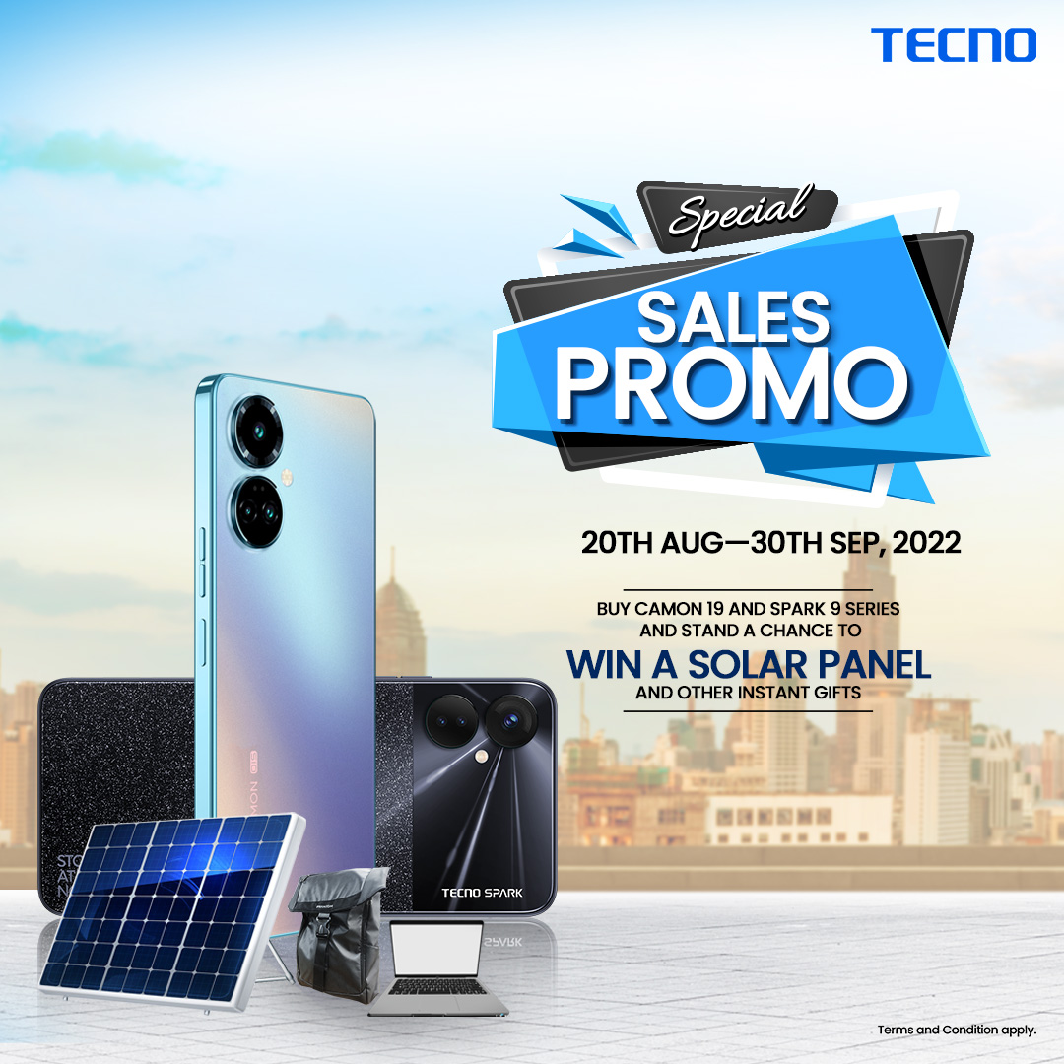

Nigeria’s biggest smartphone company, TECNO is here with another promo called the “Special Sales Promo”. In this promo, customers stand a chance to win gift items such as solar panels, and back-to-school gift bags which include laptops, customized headsets, and so much more.
This promo is open to both online and offline fans, and here is how to participate.

For offline fans:
- Walk into any authorised TECNO store and purchase any Spark 9 or Camon 19 series.

- Upon buying it, you will get an instant branded gift from TECNO, such as Bluetooth speakers, Air Pods, and power banks.

- Alongside the gifts, you will be given a raffle ticket which will qualify you to win either the solar panel or the back-to-school bag.

- Every week, there will be a draw and 21 customers will stand a chance to win the back-to-school bags.

- At the end of the promo, there will be a final draw where 3 customers will win 3 solar-powered inverter batteries.

For online fans, here is how to participate:
- Grab your phones and stay tuned to news on all TECNO social media pages.

- Make sure you participate in the trivia and activities related to the TECNO special sales promo.

- Winners would stand a chance to win branded items from TECNO.

The promo has already started, so be one of the first ones to win these prizes. This promo ends on the 30th of September.

Hurry to the nearest authorised TECNO store right now and start winning.

